NATIONAL JUNIOR COLLEGE
PRELIMINARY EXAMINATIONS
Higher 2

MATHEMATICS 9740/02 Paper 2 17 September 2012
3 hours
Additional Materials: Answer Paper List of Formulae (MF15) Cover Sheet 1400 – 1700 hours
READ THESE INSTRUCTIONS FIRST
Write your name, registration number, subject tutorial group, on all the work you hand in. Write in dark blue or black pen on both sides of the paper. You may use a soft pencil for diagrams or graphs. Do not use paper clips, highlighters, glue or correction fluid.
Answer all the questions. Give non-exact numerical answers correct to 3 significant figures, or 1 decimal place in the case of angles in degrees, unless a different level of accuracy is specified in the question. You are expected to use a graphic calculator. Unsupported answers from a graphic calculator are allowed unless a question specifically states otherwise. Where unsupported answers from a graphic calculator are not allowed in a question, you are required to present the mathematical steps using mathematical notations and not calculator commands. You are reminded of the need for clear presentation in your answers.
At the end of the examination, fasten all your work securely together. The number of marks is given in the brackets [ ] at the end of each question or part question.
This document consists of 8 printed pages and 0 blank page.
 National Junior College
Section A: Pure Mathematics [40 marks]
1(a) Given that 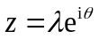,where 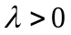and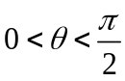, and 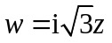, find
(i) 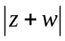, in terms of , [2] (ii) 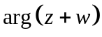, in terms of . [2]

(b) The complex number z satisfies the relations
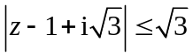 and 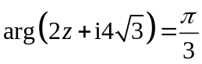.
(i) Illustrate, on an Argand diagram, the locus of points representing the complex number z. [3]
(ii) Find the exact value of z that gives the greatest possible value of arg(z). [3]

2(a) A car C is traveling at a bearing of 010º towards intersection P at a rate of 60 km/h while a
truck T is at rest, 48 km at a bearing of 070º away from the intersection.
Car C
Truck T
P
48 km
010º
070º
N

By using Cosine Rule, show that the square of the distance, y², between the car C and truck T is 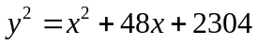, when the car C is x km from intersection P. [1]
Find the rate of change of the distance between the car C and truck T when the car is 15 km from of the intersection. [3]

(b)
r
r
r

A closed cylindrical container with a hemispherical base is constructed to store water. The cost of each unit area of the circular top is fixed at P dollars and the cost of each unit area of the curved surface and hemispherical base of the cylinder is fixed at 3P dollars. The total cost of the surface is a fixed amount, C dollars.
Given that the radius of the hemisphere is r, show that the volume V of the structure can be expressed as V 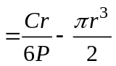. [3]
Show that, as r varies, V is at its maximum value when the cost of circular top is 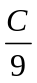 dollars. [3]
[Curved surface area of hemisphere = 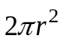; volume of hemisphere = 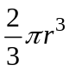]

3(a) By expressing 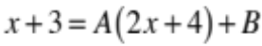, where A and B are constants to be determined, evaluate
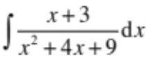. [4]
(b) A curve 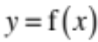, defined for 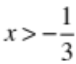, has gradient value of 2 at the point 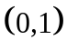. Given further that 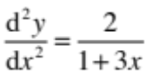, find the equation of the curve. [6]

4 (i) Without using integration, state the exact value of 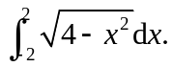 Justify your answer. [2]
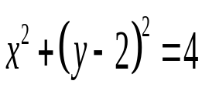
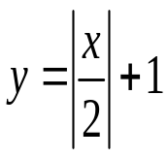
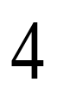
(ii) Let the region bounded by the curves whose equations are 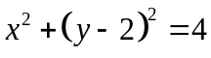 and 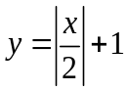 be R. Show that the volume of solid generated when R is rotated completely about the x-axis can be expressed as 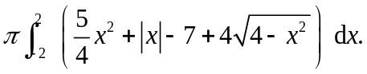 Hence find this volume in its exact form. [8]
R
x
y
O
1

Section B: Statistics [60 marks]

5 The organiser of the international YAYA musical concert desires to sample 2% of the audience to find their opinions of the venue facilities.
(i) Describe how a systematic sample could be obtained. [2]
(ii) Give a reason why a stratified sample would not be easy to obtain. [1]

x | 0.5 | 1.0 | 1.5 | 2.0 | 2.5 | 3.0 | 3.5 | 4.0 | 4.5 | 5.0
y | 13.1 | 12.9 | 12.5 | 11.7 | 10.9 | 9.9 | 8.9 | 7.7 | 6.0 | 4.1
6 The table below gives the values of ten observations of bivariate data, x and y.

(i) Sketch the scatter diagram and determine the value of the product moment correlation coefficient between y and x. [2]
(ii) Determine which of the following is the best model for this set of data, justifying your choice clearly.
(A) 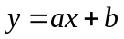 (B) 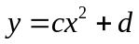 (C) 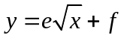 [2]
(iii) Find the equation of the least-squares regression line of your selected best model in part (ii). Use your equation to estimate the value of y when x = 3.8. Comment on the reliability of the estimation. [3]

7(a) Find the number of ways in which the letters of the word NATIONAL can be arranged if
- there are no restrictions, [1]
- not all the identical letters are next to each other, [2]
- the vowels must not be next to one another. [2]

(b) The Rational Junior College Symphonic Band comprises 4 trumpet players, 4 horn players, 3 trombone players and 4 saxophone players. A mini stage band of 9 players are to be chosen from these sections to perform for a segment of their annual concert. Find the number of ways the group can be chosen if it includes
- exactly 3 trumpet players, 2 horn players, 2 trombone players and 2 saxophone players, [2]
(ii) at least 3 players from each of the trumpet and saxophone sections. [3]

8 In a particular school, all students are required to have a first Co-Curriculum Activity (CCA), while it is optional to have a second CCA. For their first CCAs, 45% are in Sports, 40% are in Music and Dance, and the remaining are in Clubs and Societies. 100p% of students whose first CCA is Sports also have a second CCA. 75% of students whose first CCA is Music and Dance has no second CCA. Half of the students whose first CCA is Clubs and Societies have a second CCA.
(i) Write down the probability that a randomly selected student has a second CCA, given that his first CCA is Music and Dance. [1]
(ii) If the probability of a randomly selected student having a second CCA is 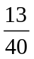, find the exact value of p. [2]
(iii) Find the probability of a randomly selected student having Clubs and Societies as his first CCA, given that he does not have a second CCA. [3]
(iv) Two students are selected at random. The events A and B are defined as follows.
A: one of the students has Music and Dance as first CCA and the other has Clubs and Societies as first CCA.
B: both students have a second CCA.
Find 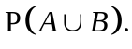 [3]

9 Kelly is a javelin thrower in her school and has been training for a long time. The distance, x metres, that she can throw her javelin is found to have a mean of 55 metres. At the beginning of the current school year, a new coach took over and started using a new training method on her which is supposed to boost her performance.
(i) After several weeks of training, the distances she threw on 10 randomly selected attempts were recorded as 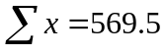 and 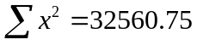. Assuming that X is normally distributed, test, at the 5% significance level, whether the new training method has improved her performance. [5]
Explain the meaning of ‘at the 5% significance level’ in the context of the question. [1]
(ii) It is given that the population standard deviation of the distances that she can throw the javelin is 6 metres. The distances she threw on another 60 randomly selected attempts were recorded. Using the same null and alternative hypotheses as in (i), an appropriate test that is carried out at the 5% significance level leads to the null hypothesis being rejected. Find the range of values of the sample mean. [3]
10 At a shopping centre, the length of time a customer leaves their vehicle in the car park on a weekday is normally distributed with mean 95 minutes and standard deviation 21 minutes.
(i) Find the probability that of three randomly selected customers who leave their separate vehicles in the car park on a weekday, two customers leave their cars in the car park for more than 120 minutes each, while the remaining customer leaves his car in the car park for between 80 and 112 minutes. [2]
On a weekend, the length of time a customer leaves his vehicle in the car park has an independent normal distribution with mean µ minutes and standard deviation σ minutes. It is given that the probability of a customer leaving his vehicle in the car park for at most 120 minutes and more than 148 minutes are 0.5 and 0.191 respectively.
(ii) Write down the value of µ and show that σ = 32, correct to nearest minute. [3]
The shopping centre offers and charges for valet parking service, in addition to the car park charges. The rates are as follows:
 | Weekday Charges ($) | Weekend Charges ($)
Valet parking service (per entry) | 2.00 | 5.00
Car park charges (per minute) | 0.04 | 0.03
In a particular week, Mr Teng drove to the shopping centre twice on weekdays and once on the weekend. He used the valet parking service on all occasions.
(iii) Find the probability that Mr Teng paid a total of not more than $18 in parking charges in the week. [3]
In the same week, Miss Low also drove to the shopping centre twice on weekdays and once on the weekend, but did not use the valet parking service at all.
(iv) Find the probability that Miss Low paid at least $10 less than Mr Teng in total. [3]
11 A particular sports hall, comprising exactly six badminton courts, is open between 0700 and 2200 every day. Courts are available for booking only at the following time slots: 0700 to 0800, 0800 to 0900, … , 2100 to 2200. Due to popular demand, each member is allowed to book one court for exactly one time slot in a day, and it can be assumed that members have no preference between any one of the 6 courts. The number of demands for a court per time slot in this sports hall on a weekend is a Poisson random variable with mean 7.2. It can be assumed that the bookings for different time slots occur independently of each other.
- (i) Show that the probability that all the six courts are booked for a particular time slot on a Saturday is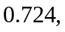 correct to 3 decimal places. [1]
- Use a suitable approximation to find the probability that all the six courts are booked for at least 20 random time slots on both Saturday and Sunday of a particular week. [4]

- Find the most probable number of demands between 0700 and 1000. [1]
(c) Calculate the approximate probability that, for 52 randomly selected Sundays, the average number of demands for a court between 0700 and 0800 per Sunday is at most 7. [3]
(d) Explain why
- a binomial distribution would probably not be valid if applied to the number of courts that are booked in a particular time period. [1]
- the Poisson distribution for the number of demands for the courts booked on a weekend would not be suitable on a weekday. [1]

End of Paper

